TUGAS PERTEMUAN 4
PERANCANGAN BASIS DATA



Disusun oleh:
Rama Pramudya Wibisana 2022320019

PROGRAM STUDI SISTEM INFORMASI
FAKULTAS INFORMATIKA
UNIVERSITAS BINA INSANI
BEKASI
2023
QUERY

CREATE TABLE CATEGORY_PROD(
ID_CATEGORY NUMBER GENERATED BY DEFAULT AS IDENTITY,
CATEGORY_NAME VARCHAR2(50) NOT NULL,
PRIMARY KEY(ID_CATEGORY)
);

CREATE TABLE PRODUCT(
ID_PRODUCT NUMBER GENERATED BY DEFAULT AS IDENTITY,
PRODUCT_NAME VARCHAR2(50) NOT NULL,
PRICE DECIMAL(12,2) NOT NULL,
CATEGORY_ID INTEGER,
PRIMARY KEY(ID_PRODUCT),
CONSTRAINT FK_CategoryProduct FOREIGN KEY
(CATEGORY_ID) REFERENCES CATEGORY_PROD(ID_CATEGORY)
);

SELECT * FROM CATEGORY_PROD;

INSERT INTO CATEGORY_PROD ( CATEGORY_NAME ) VALUES ('MAKANAN');
INSERT INTO CATEGORY_PROD ( CATEGORY_NAME ) VALUES ('MINUMAN');
INSERT INTO CATEGORY_PROD ( CATEGORY_NAME ) VALUES ('DESZERT');
INSERT INTO CATEGORY_PROD ( CATEGORY_NAME ) VALUES ('SALAD');
INSERT INTO CATEGORY_PROD ( CATEGORY_NAME ) VALUES ('SAOS');

SELECT *FROM PRODUCT;

INSERT INTO PRODUCT (PRODUCT_NAME, PRICE, CATEGORY_ID ) VALUES ('A. KAPAL SELAM', 16000, 1);
INSERT INTO PRODUCT (PRODUCT_NAME, PRICE, CATEGORY_ID ) VALUES ('A. LENJERAN UDANG', 15000, 1);
INSERT INTO PRODUCT (PRODUCT_NAME, PRICE, CATEGORY_ID ) VALUES ('B. ES JELLY KOPYOR', 13000, 2);
INSERT INTO PRODUCT (PRODUCT_NAME, PRICE, CATEGORY_ID ) VALUES ('A. PATIN', 22000, 1);
INSERT INTO PRODUCT (PRODUCT_NAME, PRICE, CATEGORY_ID ) VALUES ('A. NASI', 6000, 1);
INSERT INTO PRODUCT (PRODUCT_NAME, PRICE, CATEGORY_ID ) VALUES ('B. ES JERUK', 9000, 2);
INSERT INTO PRODUCT (PRODUCT_NAME, PRICE, CATEGORY_ID ) VALUES ('A. TAHU', 17000, 1);
INSERT INTO PRODUCT (PRODUCT_NAME, PRICE, CATEGORY_ID ) VALUES ('A. KERITING', 8000, 1);
INSERT INTO PRODUCT (PRODUCT_NAME, PRICE, CATEGORY_ID ) VALUES ('A. LENJERAN SOSIS', 7000, 1);

SELECT * FROM PRODUCT P
JOIN category_prod CP ON p.category_id = cp.id_category

CREATE TABLE TRANSAKSI(
ID_TRANSAKSI NUMBER GENERATED BY DEFAULT AS IDENTITY,
JUMLAH DECIMAL(12,2) NOT NULL,
ID_PRODUCT INTEGER,
PRIMARY KEY(ID_TRANSAKSI),
CONSTRAINT FK_Product FOREIGN KEY
(ID_PRODUCT) REFERENCES PRODUCT(ID_PRODUCT)
);

SELECT * FROM TRANSAKSI;

INSERT INTO TRANSAKSI ( JUMLAH, ID_PRODUCT ) VALUES (1,1);

SELECT * FROM TRANSAKSI;
INSERT INTO TRANSAKSI ( JUMLAH, ID_PRODUCT ) VALUES (3,2);

SELECT * FROM TRANSAKSI T
JOIN product P ON t.id_product = t.id_product

TABLE CATEGORY_PROD

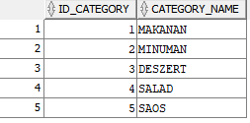

TABLE PRODUCT

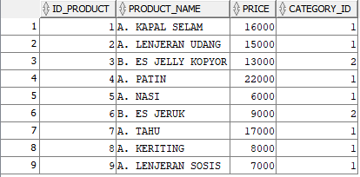

TABLE TRANSAKSI

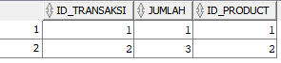

JOIN PRODUCT

